[Issue 53 - Xintang Literature and Art Recommendation] Huang Jintang | Overseas Chinese Huang Guomin's Patriotism After Following Sun Yat-sen's Revolution
This article was originally published in the "Reading Under the Lamp" column of *Xintang Literature and Art* (Issue 2, 2020) titled: Overseas Chinese Huang Guomin's Patriotism After Following Sun Yat-sen's Revolution.
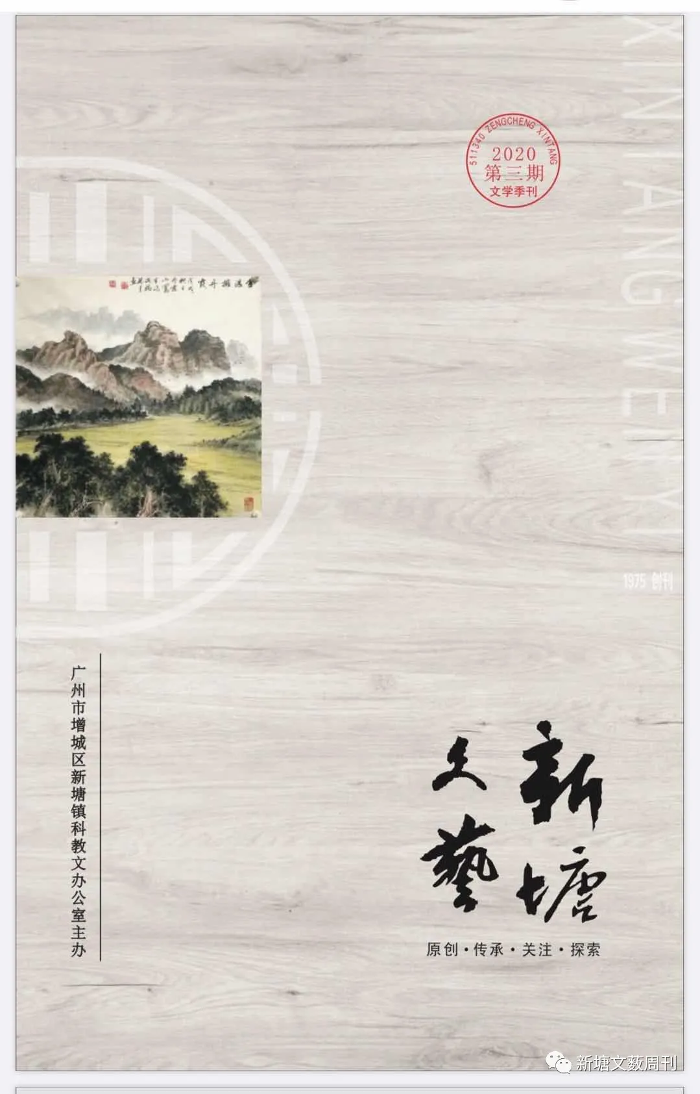
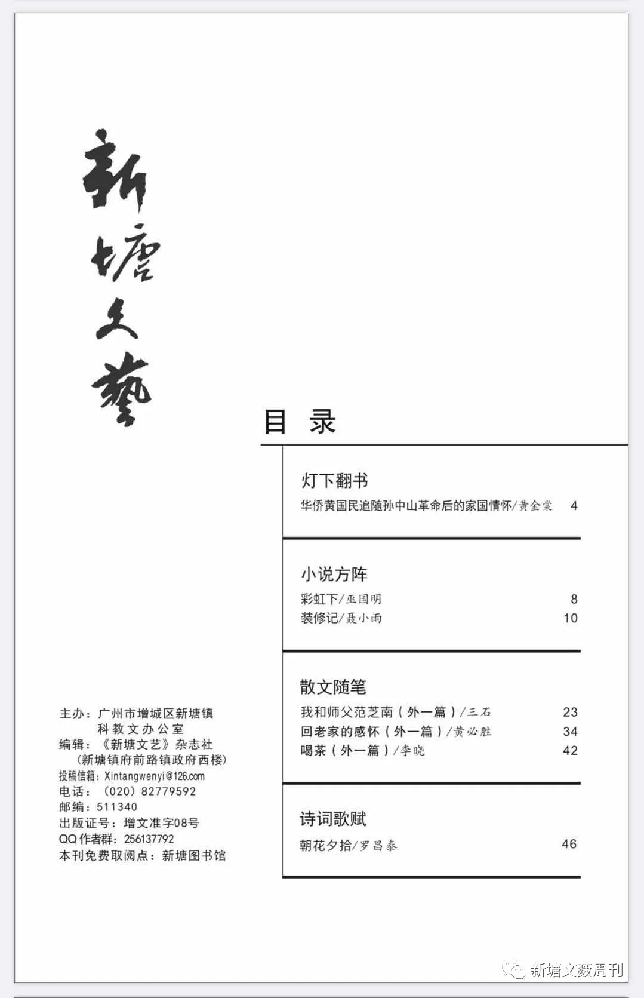
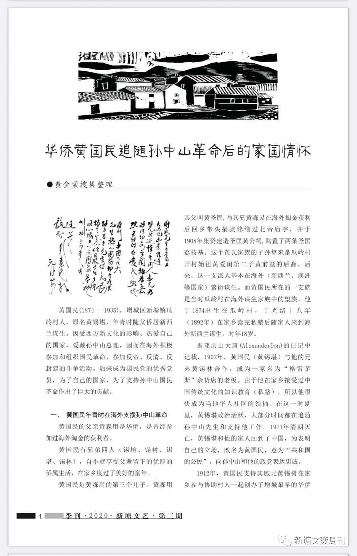
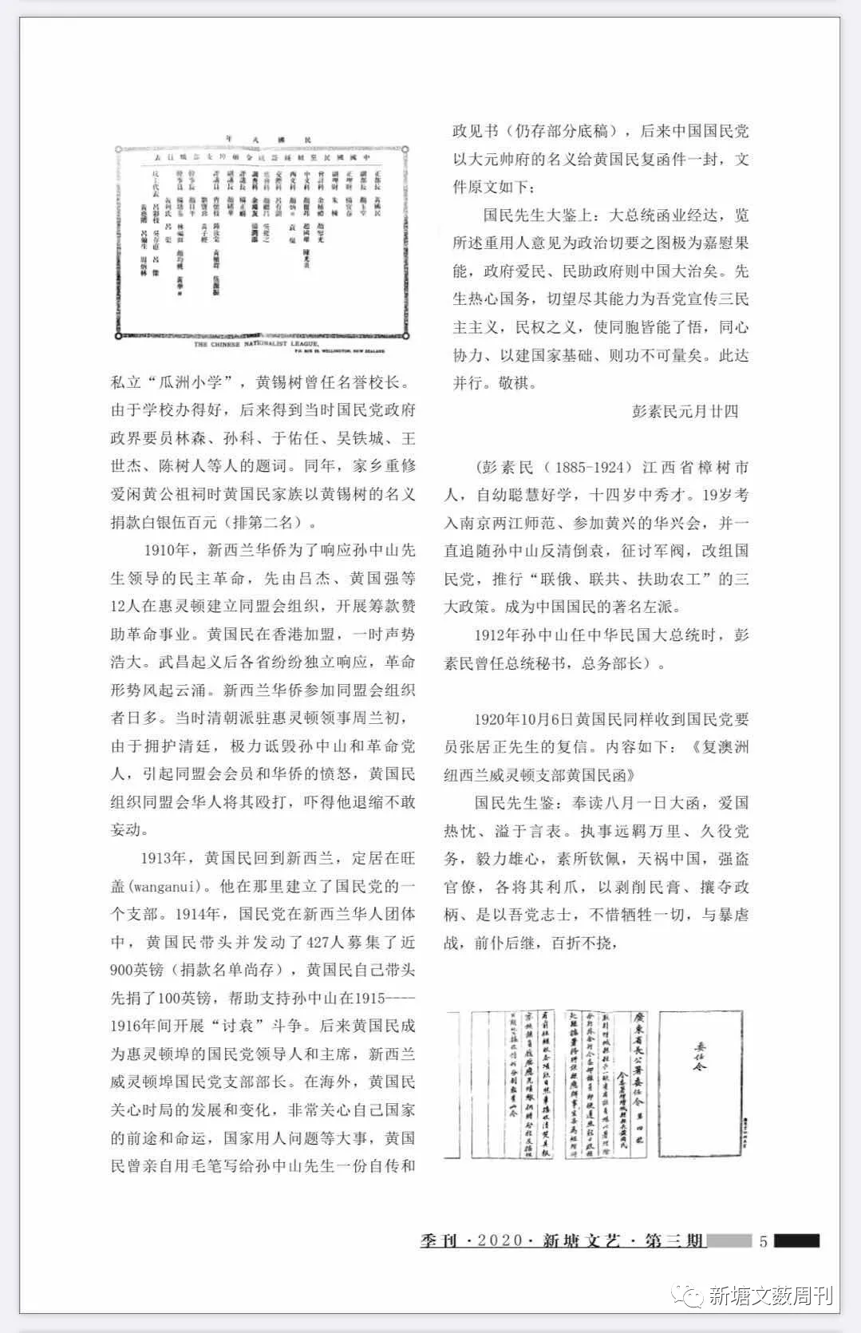
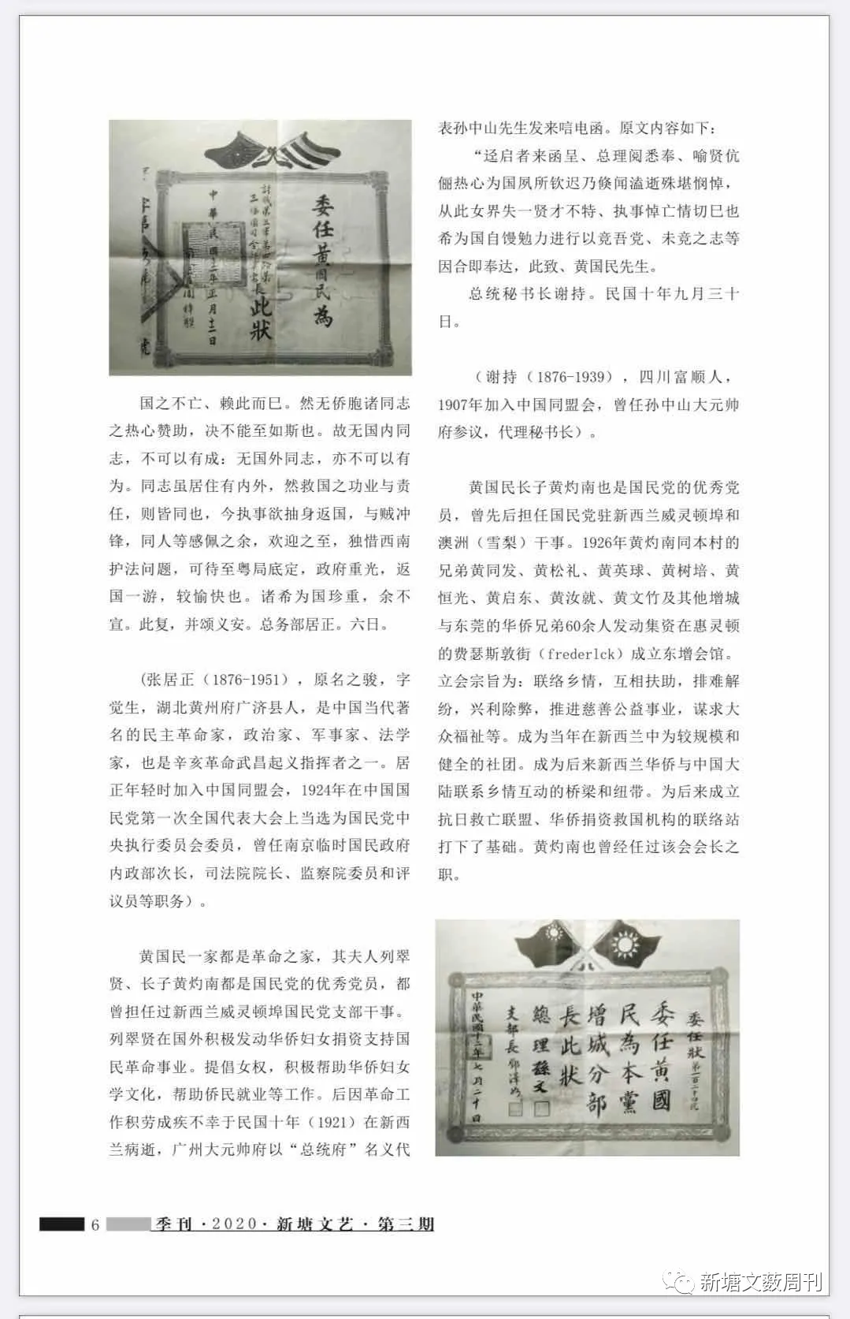
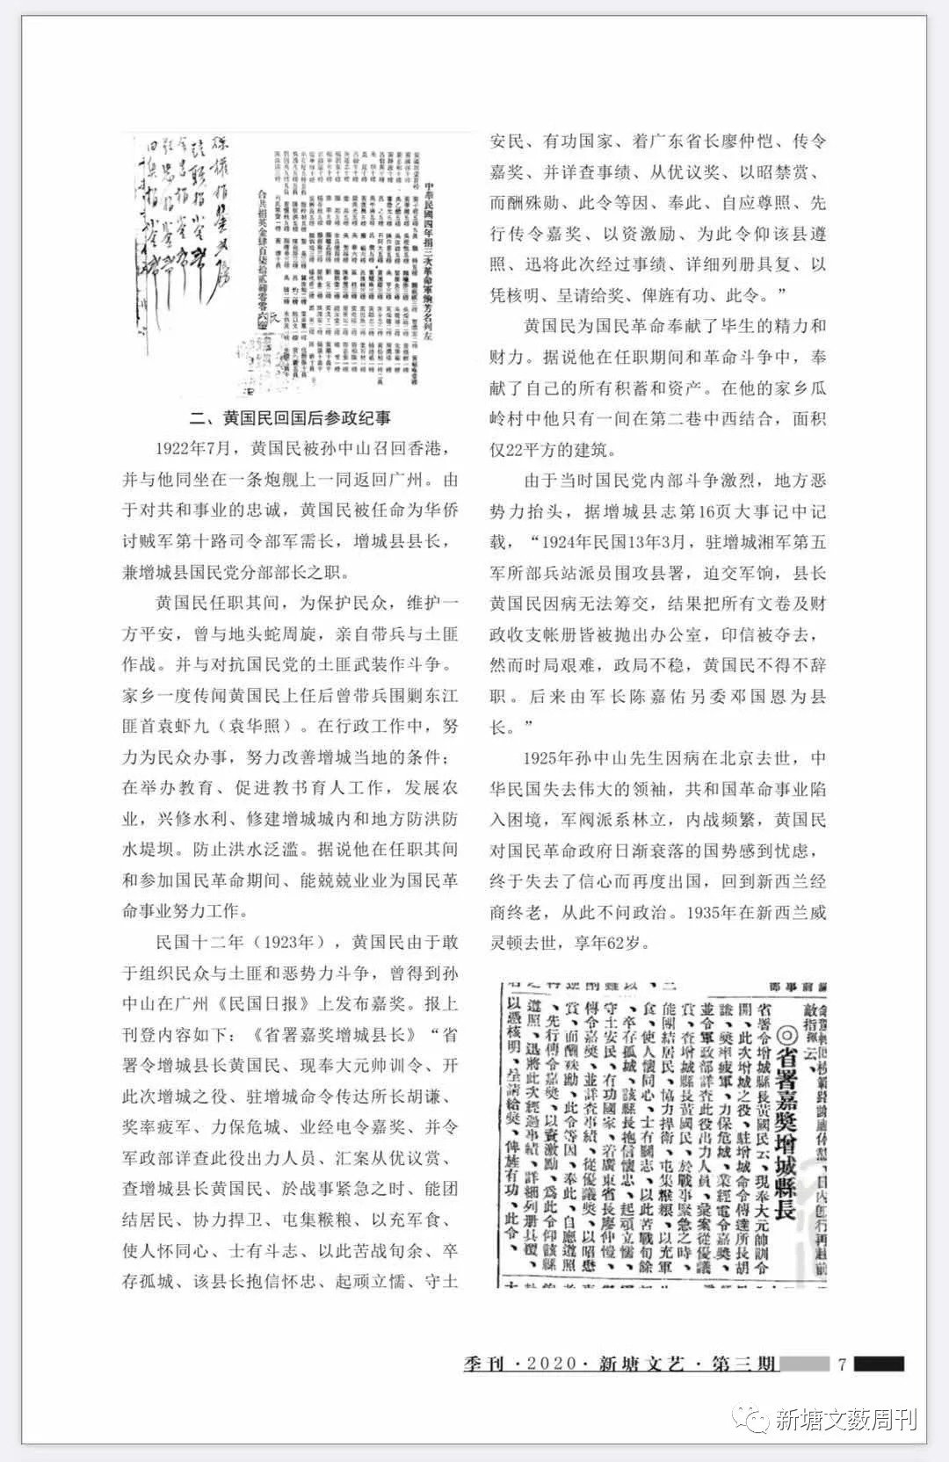

Overseas Chinese Huang Guomin's patriotism after following Sun Yat-sen's revolution
Huang Jintang collected and organized

Huang Guomin (Wong Kwok-min aka Wong Sik-Hum 1874-1935) a native of Gualing Village, Xintang Town, Zengcheng District, whose original name was Huang Xiqin, lived in New Zealand with his father in his youth to make a living. Influenced by Western culture and loving his country, he admired Sun Yat-sen and actively participated in and organized the National Revolution overseas, engaging in anti-imperialist, anti-Qing, and anti-feudal struggles. Later, he became an outstanding member of the Kuomintang, making significant contributions to his country and to supporting Sun Yat-sen's National Revolution .
Huang Guomin supported Sun Yat-sen's revolution overseas in his youth.
Huang Guomin's father, Huang Senyong, was an overseas Chinese who had profited from overseas gold mining. Huang Guomin had four brothers (Xi Pei, Xi Shu, Xi Kan, and Xi Lin). He enjoyed a comfortable life as an overseas Chinese family from his father's generation and spent a wonderful childhood in his hometown.
Huang Guomin was the third son. Huang Senyong's father, Huang Shengkuang, and his brother, Huang Senling, returned to their hometown after making money overseas by trading gold. They spearheaded donations to repair the Beidi Temple and, in 1908 raised funds to build the Shengkuang Huang Ancestral Hall, purchasing two Shengkuang lychee trees. The descendants of this Huang family are descendants of Huang Qianshu, the second son of Huang Aixian, the founding ancestor of Gualing Village. Later, this branch mainly settled and made a living overseas (in countries such as New Zealand and Australia) . Huang Guomin's branch was a prominent family among the Gualing Village families who made a living overseas at that time. He was born in Gualing Village in 1874. After finishing his private school education in his hometown in 1892, he came to New Zealand with his family to make a living at the age of 18.
According to Alexander Don's diary, in 1902, Huang Guomin (Huang Xiqin) partnered with his brother Huang Xilin to become the owner of a grocery store called “Greymouth.”
Having received a traditional Chinese education (private school) in his hometown, he quickly became a leader in the local Chinese community. During this period, Huang Xiqin was politically active, spending most of his time following and supporting Sun Yat-sen's work. In 1911, with the fall of the Qing Dynasty, Huang Xiqin and his family returned to China. To demonstrate his loyalty, he changed his name to Huang Guomin, meaning "citizen of the Republic," expressing his devotion to Sun Yat-sen and his party.
In 1912, Huang Guomin supported his elder brother Huang Xishu in helping villagers establish the earliest private overseas Chinese primary school in Zengcheng, "Guazhou Primary School," with Huang Xishu serving as its honorary principal. Due to the school's success, it later received inscriptions from prominent figures in the Kuomintang government, including Lin Sen, Sun Ke, Yu Youren, Wu Tiecheng, Wang Shijie, and Chen Shuren. That same year, when the ancestral hall of the Aixian Huang family was renovated in their hometown, Huang Guomin's family donated 500 silver dollars in Huang Xishu's name (ranking second)
In 1910, in response to the democratic revolution led by Sun Yat-sen, overseas Chinese in New Zealand first established the Tong Meng Hui (Revolutionary Alliance) in Wellington, led by Lü Jie and Huang Guoqiang, among 12 others, to raise funds for the revolutionary cause. Huang Guomin joined in Hong Kong, and the organization quickly gained momentum. After the Wuchang Uprising, various provinces declared independence in response, and the revolutionary situation surged. The number of overseas Chinese in New Zealand joining the Tongmenghui increased daily. At that time, Zhou Lanchu, the Qing Dynasty's consul in Wellington, supported the Qing government and vehemently denigrated Sun Yat-sen and revolutionaries, incurring the anger of Tongmenghui members and overseas Chinese. Huang Guomin organized Tongmenghui members to beat him, frightening him into backing down and refraining from further action.
In 1913, Huang Guomin returned to New Zealand and settled in Wanganui. There, he established a branch of the Kuomintang (KMT) In 1914, Huang Guomin led 427 members of the KMT's Chinese community in New Zealand to raise nearly £900 (the list of donors still exists). Huang Guomin himself donated £100 to support Sun Yat-sen's anti-Yuan Shikai struggle in 1915-1916. Later, Huang Guomin became the leader and chairman of the KMT in Wellington, New Zealand, and the head of the Wellington branch of the KMT. While overseas, Huang Guomin was concerned about the development and changes in the political situation and deeply concerned about the future and destiny of his country, as well as important issues such as the selection of officials. Huang Guomin personally wrote an autobiography and political statement to Sun Yat-sen with a brush pen (partial drafts still exist). Later, the KMT, in the name replied to Huang Guomin with a letter, the original text of which is as follows.
“To Mr. Guomin: The President's letter has arrived. I am greatly pleased to read your advice on appointing the right people, which is a crucial political strategy. If the government loves its people and the people support the government, then China will be well-governed. You are enthusiastic about national affairs and earnestly hope that you will do your utmost to promote the Three Principles of the People and the meaning of civil rights for our Party, so that all our compatriots can understand them and work together to build the foundation of our nation. Such an achievement would be immeasurable. This letter is sent in full. With best regards.”
Peng Sumin, January 24
Peng Sumin (1885-1924) a native of Zhangshu City, Jiangxi Province, was intelligent and studious from a young age, passing the imperial examination at the age of fourteen. At nineteen, he entered Nanjing Liangjiang Normal School, joined Huang Xing's Huaxing Society, and consistently followed Sun Yat-sen in opposing the Qing Dynasty and Yuan Shikai, fighting against warlords, reorganizing the Kuomintang, and promoting the Three Great Policies of "alliance with Russia, alliance with the Communists, and assistance to peasants and workers." He became a prominent leftist in Chinese history.
When Sun Yat-sen served as President of the Republic of China in 1912 Peng Sumin served as his presidential secretary and Minister of General Affairs.
On October 6, 1920, Huang Guomin also received a reply from Zhang Juzheng, a high-ranking official of the Kuomintang. The content is as follows: "Reply to Huang Guomin of the Wellington Branch, New Zealand, Australia"
Dear Mr Guomin: I have read your letter of August 1st, in which your patriotic fervour is overflowing. I have long admired your perseverance and ambition, having served far from home and devoted yourself to party affairs for so long. Facing the calamities of China, with its thuggish bureaucrats using their claws to exploit the people and seize power, it is precisely because of this that our party's patriots are willing to sacrifice everything to fight against tyranny, advancing wave upon wave, undeterred by any setback.
The nation's survival depends on this. However, without the enthusiastic support of our overseas comrades, this would never have been possible. Therefore, without comrades within the country, there can be no achievement; without comrades abroad, there can be no accomplishment. Although comrades reside in different places, their contributions and responsibilities in saving the nation are the same. Now, you wish to return to the country to fight the enemy. We are deeply moved and warmly welcome you. We only regret the Southwest's constitutional protection issue; it would be more pleasant to return after the situation in Guangdong is stabilized and the government is restored. We hope you will take care of yourselves for the sake of the nation. This is our reply, and best wishes to Yi'an. General Affairs Department, Juzheng. 6th.
(Zhang Juzheng (1876-1951) originally named Zhijun, courtesy name Juesheng, was a native of Guangji County, Huangzhou Prefecture, Hubei Province. He was a renowned contemporary Chinese democratic revolutionary, politician, military strategist, and jurist, and one of the commanders of the Wuchang Uprising during the Xinhai Revolution. In his youth, Juzheng joined the Tong Meng Hui (Chinese Revolutionary Alliance). In 1924, at the First National Congress of the Kuomintang, he was elected a member of the Central Executive Committee of the Kuomintang. He served as Vice Minister of the Interior of the Nanjing Provisional National Government, President of the Judicial Yuan, member of the Control Yuan, and councillor, among other positions)
The Huang Guomin family was a revolutionary family. His wife, Lie Cuixian, and eldest son, Huang Zhuonan, were both outstanding members of the Kuomintang (KMT) and had served as officers in the KMT branch in Wellington, New Zealand. Lie Cuixian actively mobilized overseas Chinese women to donate funds to support the National Revolution. She advocated women's rights and actively helped overseas Chinese women learn to read and write and assisted them in finding employment. Later, due to overwork in revolutionary work, she unfortunately passed away in New Zealand in 1921. The Guangzhou Grand Marshal's Office, on behalf of Sun Yat-sen in the name of the "Presidential Office," sent a telegram of condolence. The original text is as follows:
“Your letter is hereby presented. I have read and received it. I have long admired the virtuous couple for their dedication to the country. It is deeply saddening to hear of their sudden passing. The women's world has lost a talented woman. I am deeply saddened by their passing. I hope you will continue to work hard for the country and fulfil your unfulfilled aspirations. I hereby convey this to you, Mr. Huang Guomin."
Presidential Secretary-General Hsieh Chi. September 30th, 1921.
(Xie Chi (1876-1939) a native of Fushun, Sichuan, joined the Tong Meng Hui in 1907 and served as a counsellor and acting secretary-general of Sun Yat-sen's Grand Marshal's Office)
Huang Guomin's eldest son, Huang Zhuonan, was also an outstanding member of the Kuomintang (KMT) serving successively as a KMT official in Wellington, New Zealand, and Sydney, Australia. In 1926, Huang Zhuonan, along with his brothers from Zengcheng and Dongguan - Huang Tongfa, Huang Songli, Huang Yingqiu, Huang Shupei, Huang Hengguang, Huang Qidong, Huang Rujiu, Huang Wenzhu, and over 60 other overseas Chinese from Zengcheng and Dongguan—raised funds to establish the Dong Zeng Association on Frederick Street in Wellington. The association's founding principles were to foster kinship, provide mutual assistance, resolve disputes, promote beneficial causes and eliminate harmful ones, advance charitable and public welfare undertakings, and seek the well-being of the masses. It became one of the larger and more established community organizations in New Zealand at the time, serving as a bridge and link between overseas Chinese in New Zealand and mainland China. It laid the foundation for the later establishment of the Anti-Japanese National Salvation Alliance and liaison stations for overseas Chinese donations for national salvation. Huang Zhuonan also served as the association's president.
II. Huang Guomin's Political Participation After Returning to China
In July 1922 Huang Guomin was summoned back to Hong Kong by Sun Yat-sen, and they returned to Guangzhou together on a gunboat. Due to his loyalty to the cause of the republic, Huang Guomin was appointed as the quartermaster of the 10th Route Army of the Overseas Chinese Anti-Bandit Army, the magistrate of Zengcheng County, and the head of the Kuomintang branch in Zengcheng County.
During his tenure, Huang Guomin, in order to protect the people and maintain local peace, dealt with local bullies and personally led troops in battles against them. He also fought against bandit forces opposing the Kuomintang. Local rumours circulated that after taking office, Huang Guomin led troops to suppress the Dongjiang bandit leader Yuan Xiajiu (Yuan Huazhao). In his administrative work, he strived to serve the people and improve local conditions in Zengcheng; he promoted education, fostered agriculture, and constructed water conservancy projects, including the construction of flood control dikes within and around Zengcheng to prevent flooding. It is said that during his tenure and participation in the National Revolution, he worked diligently for the cause of the National Revolution.
In 1923, Huang Guomin was commended by Sun Yat-sen in the Guangzhou-based *Republic Daily* for his courage in organizing the people to fight against bandits and evil forces. The article reads as follows: “Provincial Government Commends Zengcheng County Magistrate Huang Guomin: The Provincial Government has ordered Zengcheng County Magistrate Huang Guomin, who, following the instructions of the Grand Marshal, led the troops in the Zengcheng campaign. Hu Qian, the garrison commander in Zengcheng, has been commended for leading the exhausted troops and defending the besieged city. The Ministry of Military Affairs has been ordered to thoroughly investigate the personnel who contributed to this campaign and to compile a list of those to be rewarded accordingly. It has been found that Zengcheng County Magistrate Huang Guomin, in the midst of the urgent battle, was able to unite the residents, cooperate in defending the city, and stockpile provisions to supply the army, thus fostering unity and fighting spirit among the people, enabling them to fight for over ten days.” “The county magistrate, having survived the isolated city, upheld faith and loyalty, rallied the weak and subdued, defended the territory and ensured the people's safety, thus rendering meritorious service to the nation. Governor Liao Zhongkai of Guangdong Province hereby issues an order to commend him, and to thoroughly investigate his achievements, deliberate on the best possible reward, so as to demonstrate that rewards should not be given in the past, and to reward those who have made outstanding contributions. Therefore, this order is hereby issued, and the county magistrate is hereby ordered to comply, promptly compile a detailed record of the events and achievements, submit it for verification, and request that an award be given to recognize his meritorious service.”
Huang Guomin dedicated his entire life and resources to the National Revolution. It is said that during his tenure and the revolutionary struggle, he donated all his savings and assets. In his hometown of Gualing Village, he owned only a small, 22-square-meter building in the second alley, a blend of Chinese and Western architectural styles.
Due to intense internal struggles within the Kuomintang and the rise of local evil forces, the Zengcheng County Gazetteer records on page 16,
“In March 1924 (the 13th year of the Republic of China) the supply depot of the Fifth Army of the Hunan Army stationed in Zengcheng sent personnel to besiege the county government office, demanding payment of military funds. County Magistrate Huang Guomin, due to illness, was unable to collect the funds, resulting in all documents and financial records being thrown from his office, and his official seal being confiscated. However, given the difficult political situation and instability, Huang Guomin was forced to resign. Later, Army Commander Chen Jiayou appointed Deng Guoen as the new county magistrate.”
In 1925, Dr. Sun Yat-sen passed away in Beijing due to illness. The Republic of China lost its great leader, and the revolutionary cause of the Republic fell into difficulties. Warlord factions arose, and civil wars were frequent. Huang Guomin was worried about the declining national power of the National Revolutionary Government. He finally lost confidence and went abroad again, returning to New Zealand to do business until his death, and never involved himself in politics again. He died in Wellington, New Zealand in 1935 at the age of 62.

Images mentioned in the article
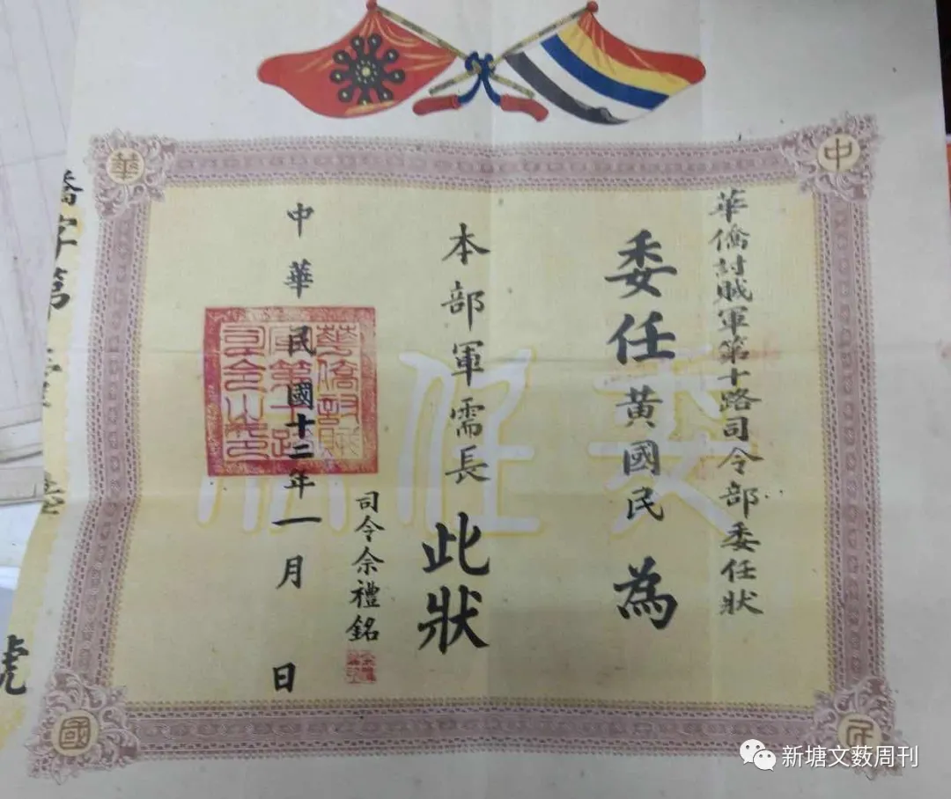
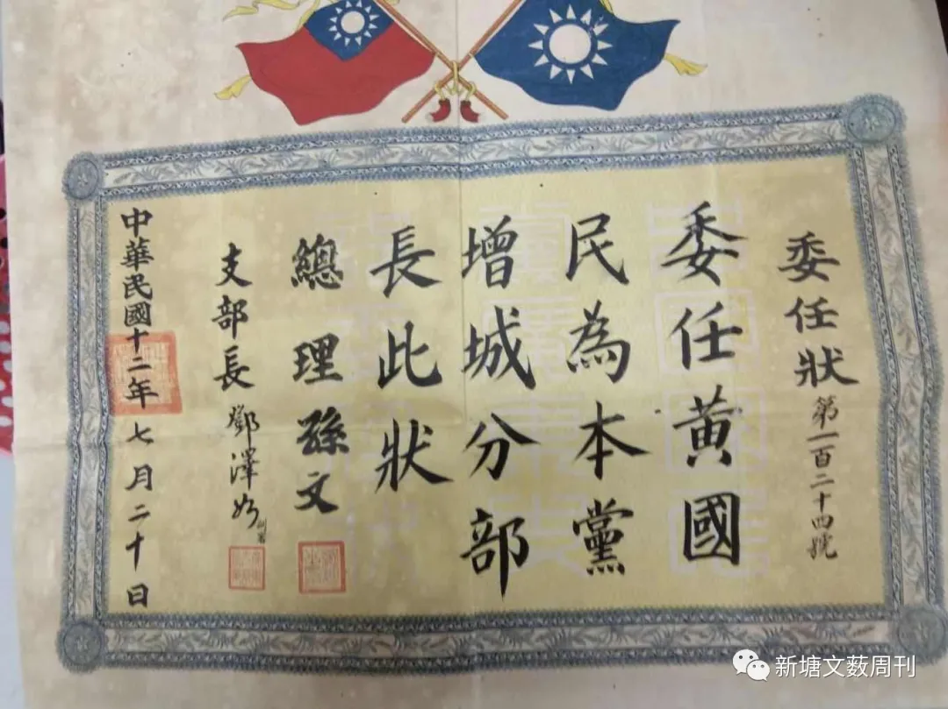
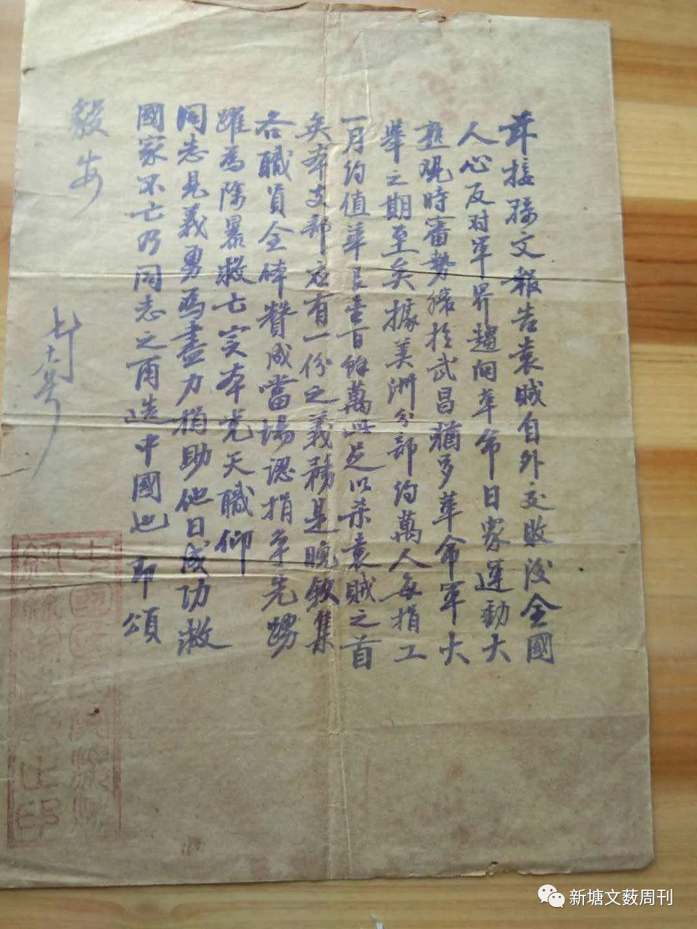
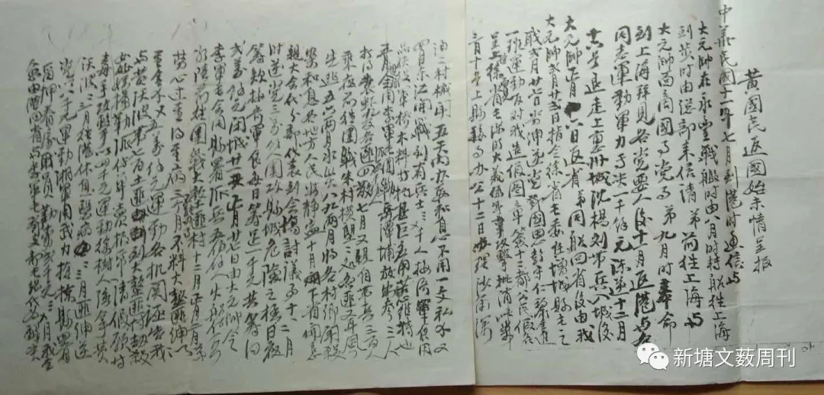
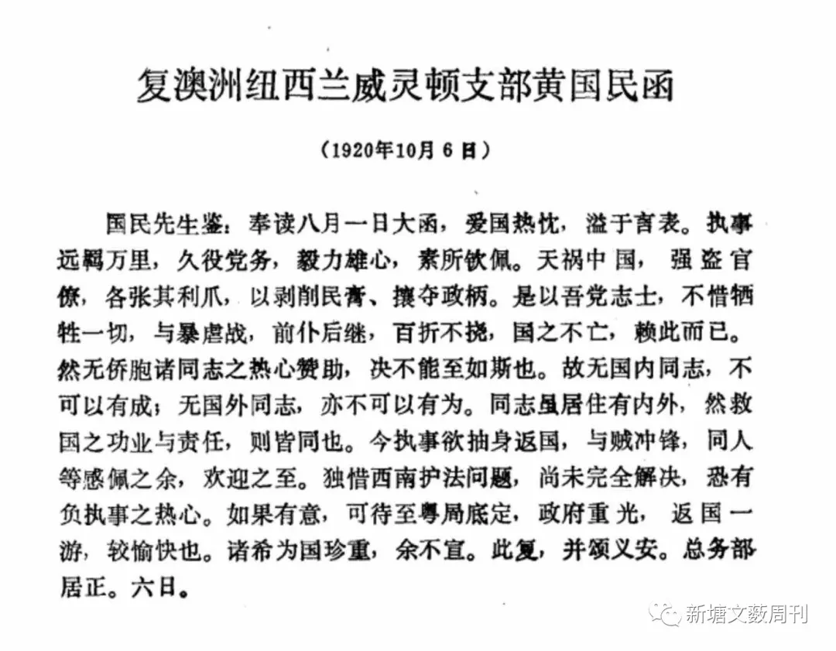
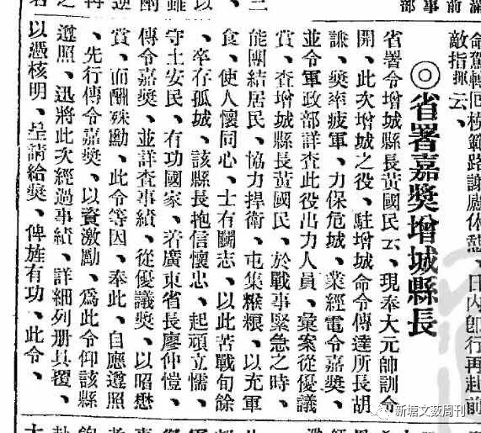
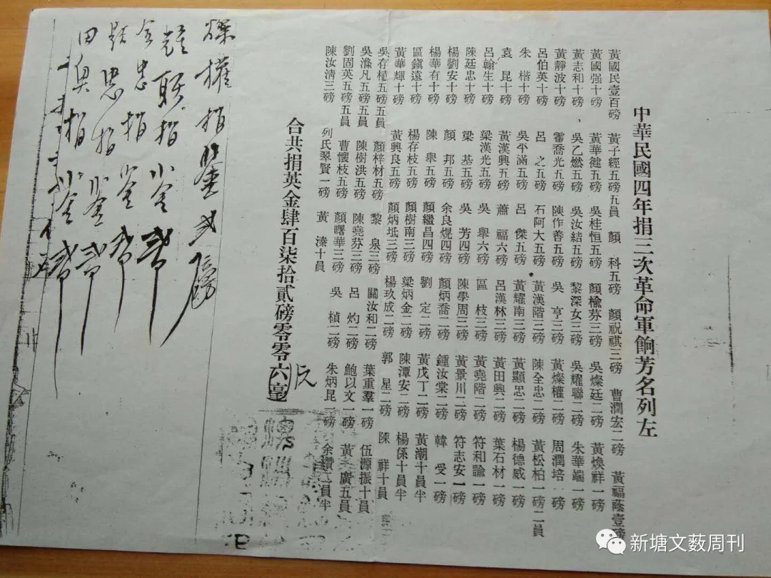
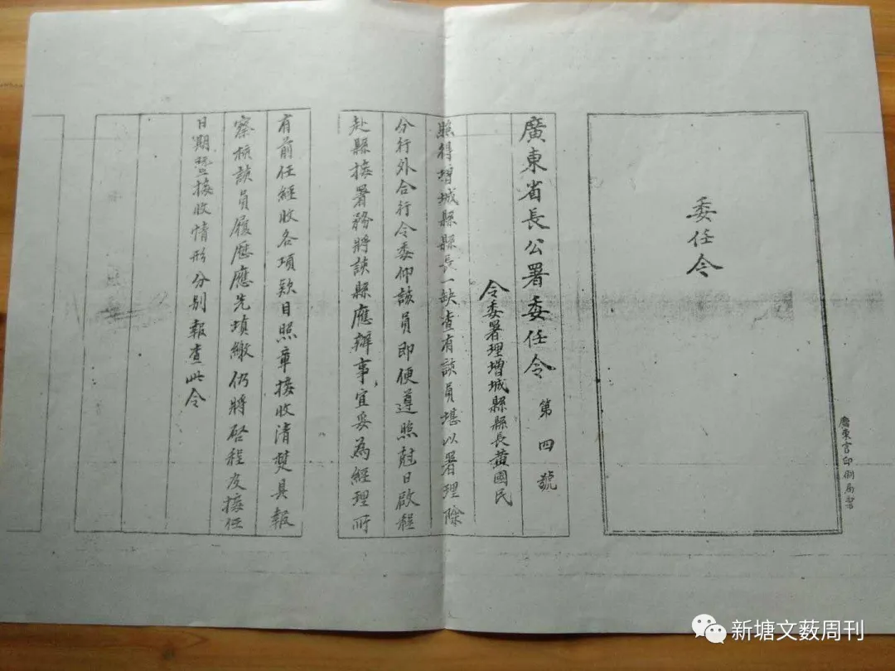
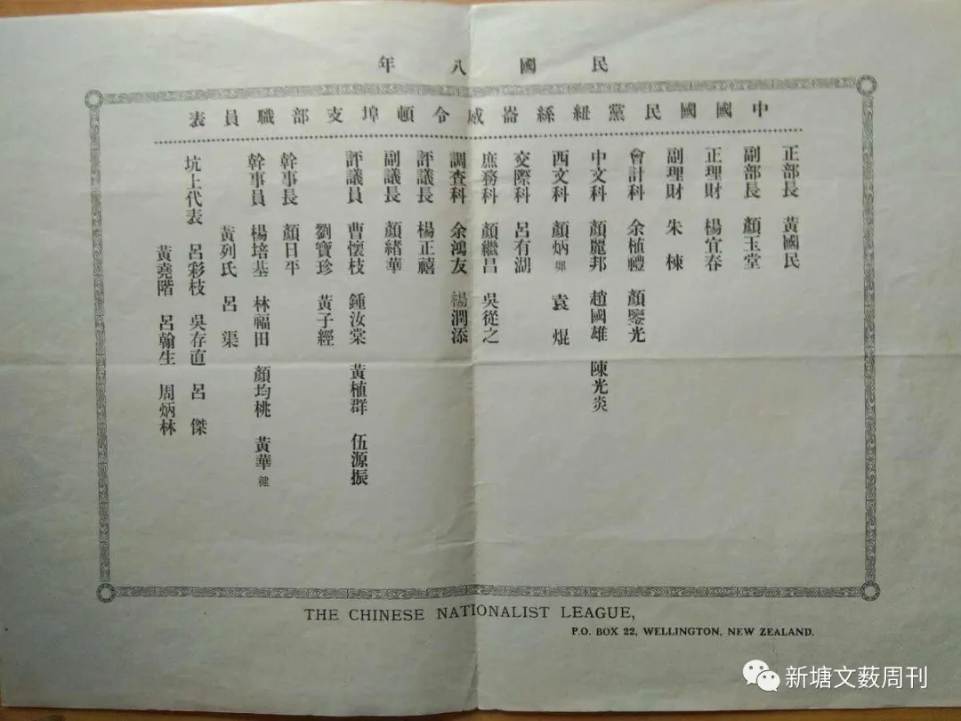
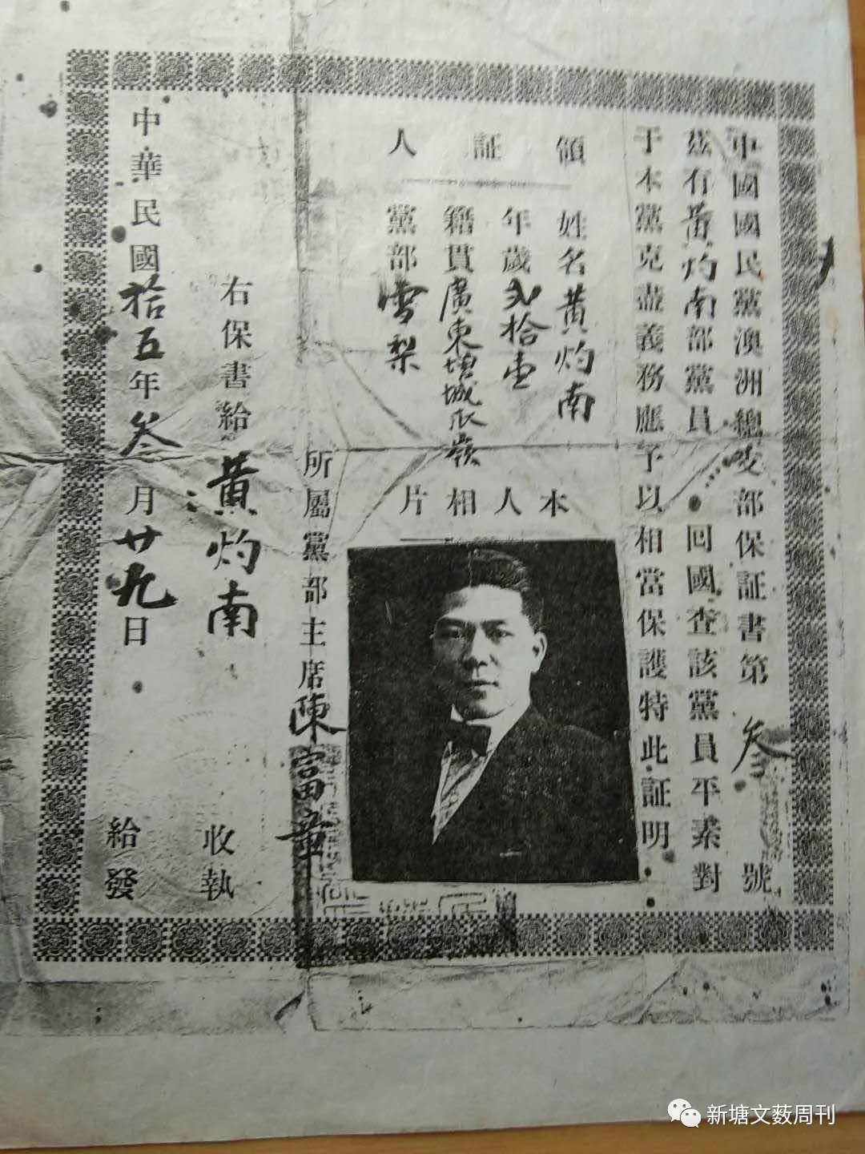
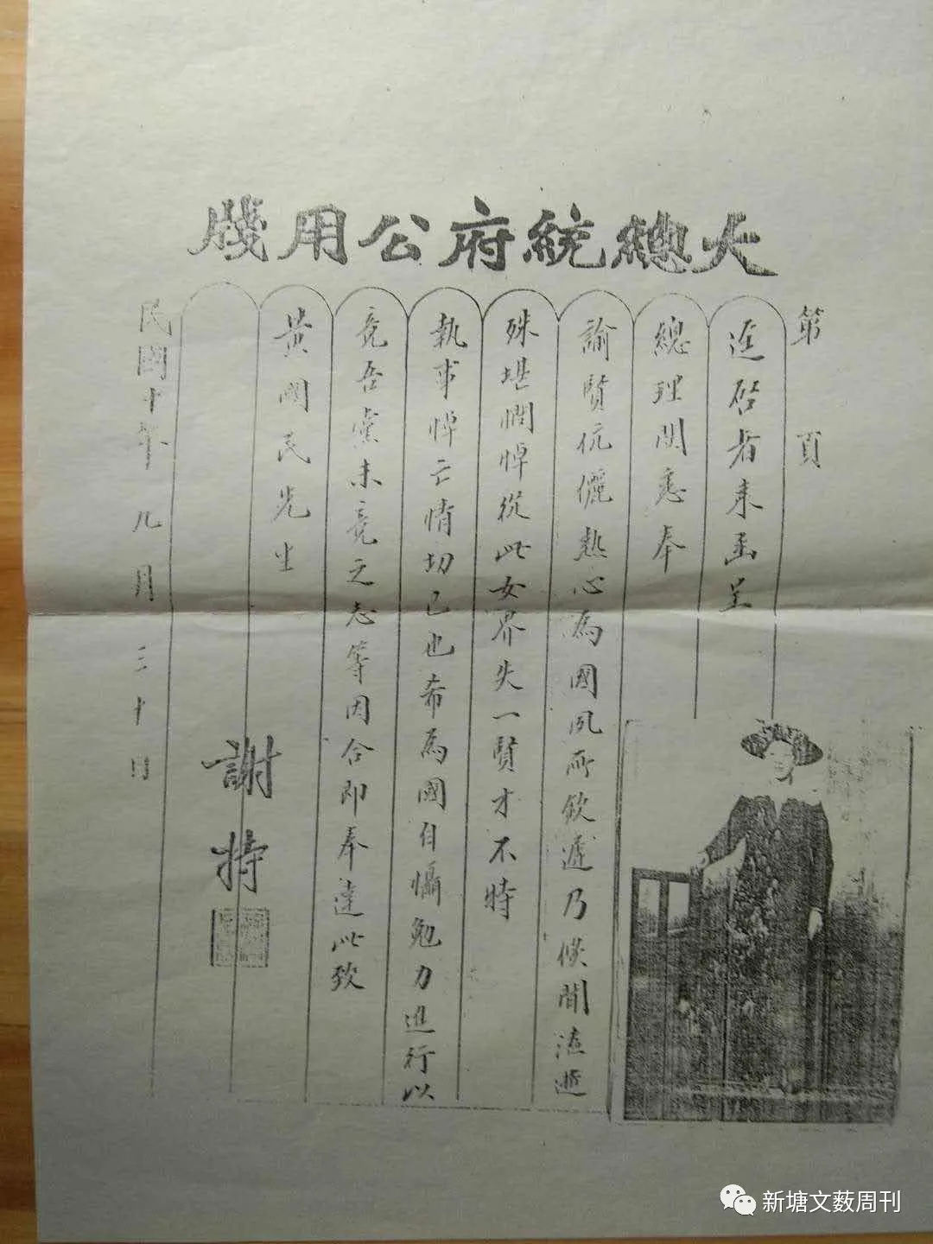
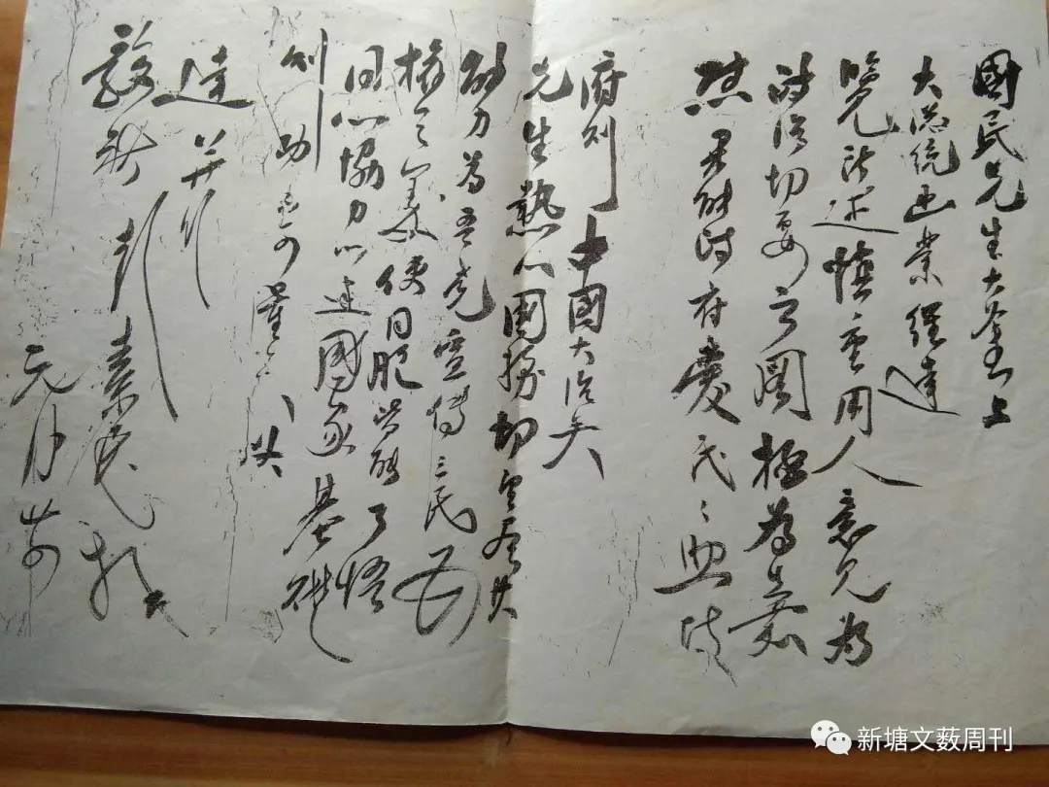
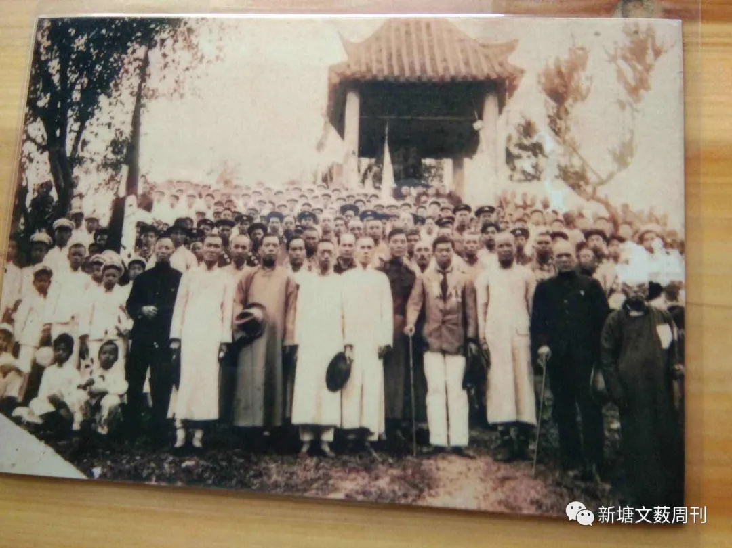
About the Author
Golden Tang
A native of Gualing Village, Xintang Town, Zengcheng District, and the former Party Branch Secretary of Gualing Village, he has long been dedicated to amateur poetry writing and historical research. His published works include *Guazhou Yin Cao*, *Guazhou, the Hometown of Overseas Chinese*, and *Every Wave is a Song of the Baishi River—Stories Told Along the Baishi River*. *Guazhou Yin Cao* won second prize in the 6th Zengcheng City Literary Poetry and Couplets Competition; *Guazhou, the Hometown of Overseas Chinese* was translated into English by overseas Chinese in New Zealand. He is currently a member of the Chinese Poetry Association, the Guangzhou Folk Artists Association, and the Guangzhou Yangcheng Poetry Society.
Brief Introduction to Xintang Literature and Art
Founded in 1975, *Xintang Literature and Art* was a small literary magazine, handwritten with fountain pen and mimeographed on stencil paper. Adhering to the principle of "reform and opening up, serving the local community," it received widespread support from local literature enthusiasts. The novels, essays, poems, folk arts, and folk tales published in *Xintang Literature and Art* were frequently reprinted in newspapers and magazines such as *Yangcheng Evening News*, *Guangzhou Daily*, *Guangdong Farmers' Daily*, *Guangdong Literature and Art*, *Guangzhou Literature and Art*, and *Kapok Flower*. *Guangdong Farmers' Daily* also co-edited two issues of the *Lingnan* literary supplement with the Xintang Cultural Station, selecting 19 works by Xintang authors. In 1997, *Xintang Literature and Art* underwent a redesign in terms of both content and layout, attracting attention from the literary community. The first issue of *Guangzhou Artists* in 1998 featured 24 works by Xintang authors. In September 2005, *Xintang Literature and Art* was invited as the sole representative from Guangzhou to participate in the Guangdong Provincial Township-Level Literary Creation Symposium, where it received commendation from the Guangdong Provincial Writers Association. In early 2006, to commemorate the 30th anniversary of its founding, *Xintang Literature and Art* published a collection of selected literary works, *Xintang Literary Anthology*, injecting a new chapter into Xintang culture. Books such as *Selected Folk Tales of Xintang* and *Every Wave is a Song of the Baishi River—Stories Told Along the Baishi River* were also edited and published by *Xintang Literature and Art*.
The magazine "Works," sponsored by the Guangdong Writers Association, featured Xintang Literature and Art as an "Internal Publication Star" in its 7th issue of 2020.
Column host
Long Ling
A member of the Guangdong Provincial Writers Association, vice chairman of the Zengcheng District Writers Association, and editor-in-chief of *Xintang Literature and Art*. His poems, created in 1994, were recognized as third-level literary works by the China International Literary and Art Works Expo. He has won the Ministry of Metallurgical Industry's Iron Flow Literature Award, the first Zengcheng Literary Award, and a national essay award jointly organized by *Poetry Journal*, *People's Literature*, and *Works*. He is the author of the poetry collection *Between Steel and Plum Blossom* (China Drama Publishing House). He has edited more than 10 books, including *Xintang Literature Collection*, *Selected Folk Tales of Xintang*, *Humanistic Xintang* (picture album), *Xintang Education* (picture album), and *Imprints of Xintang*. His poems have been included in numerous anthologies. In January 2015, he received the title of "Guangzhou Municipal Workers' Artist".
Contact information for this column: 574304235@qq.com
https://mp.weixin.qq.com/s/5fTR05MTXrzorhxlPpPclA

华侨黄国民追随孙中山革命后的家国情怀
黄金棠搜集整理
黄国民 (1874-1935) 增城区新塘镇瓜岭村人，原名黄锡钦，年青时随父侨居新西兰谋生。因受西方新文化的影响、热爱自己的国家，爱戴孙中山总理，因而在海外积极参加和组织国民革命，参加反帝、反清、反封建的斗争活动。后来成为国民党的优秀党员，为了自己的国家，为了支持孙中山国民革命作出了巨大的贡献。
一 黄国民年青时在海外支援孙中山革命
黄国民的父亲黄森用是华侨，是曾经参加过海外淘金的获利者。
黄国民有兄弟四人（锡培、锡树、锡堪、锡林），自小就享受父辈留下的优厚的侨属生活，在家乡度过了美好的童年。
黄国民是黄森用的第三个儿子。黄森用其父叫黄圣匡,与其兄黄森灵在海外掏金获利后回乡带头捐款修缮过北帝庙宇，并于1908年集资建造圣匡黄公祠,购置了两条圣匡荔枝基。这个黄氏家族的子孙算来是瓜岭村开村始祖黄爱闲第二子黄前墅的后裔。后来，这一支派人基本在海外（新西兰、澳洲等国家）繁衍谋生。而黄国民所在的一支就是当时瓜岭村在海外谋生家族中的望族，他于1874出生在瓜岭村，于光绪十八年（1892年）在家乡读完私塾后随家人来到海外新西兰谋生，时年18岁。
据亚历山大唐(AlexanderDon)的日记中记载，1902年，黄国民（黄锡钦）与他的兄弟黄锡林合作，成为一家名为“格雷茅斯”杂货店的老板。由于他在家乡接受过中国传统文化的知识教育（私塾），所以他很快成为当地华人社区的领袖。在这一时期里，黄锡钦政治活跃，大部分时间都在追随孙中山先生和支持他工作。1911年清朝灭亡，黄锡钦和他的家人回到了中国，为表明自己的立场，改名为黄国民，意为“共和国的公民”，向孙中山和他的政党表达忠诚。
1912年，黄国民支持其胞兄黄锡树在家乡参与协助村人一起创办了增城最早的华侨私立“瓜洲小学”，黄锡树曾任名誉校长。由于学校办得好，后来得到当时国民党政府政界要员林森、孙科、于佑任、吴铁城、王世杰、陈树人等人的题词。同年，家乡重修爱闲黄公祖祠时黄国民家族以黄锡树的名义捐款白银伍百元（排第二名）。
1910年，新西兰华侨为了响应孙中山先生领导的民主革命，先由吕杰、黄国强等12人在惠灵顿建立同盟会组织，开展筹款赞助革命事业。黄国民在香港加盟，一时声势浩大。武昌起义后各省纷纷独立响应，革命形势风起云涌。新西兰华侨参加同盟会组织者日多。当时清朝派驻惠灵顿领事周兰初，由于拥护清廷，极力诋毁孙中山和革命党人，引起同盟会会员和华侨的愤怒，黄国民组织同盟会华人将其殴打，吓得他退缩不敢妄动。
1913年，黄国民回到新西兰，定居在旺盖(wanganui)。他在那里建立了国民党的一个支部。1914年，国民党在新西兰华人团体中，黄国民带头并发动了427人募集了近900英镑（捐款名单尚存），黄国民自己带头先捐了100英镑，帮助支持孙中山在1915----1916年间开展“讨袁”斗争。后来黄国民成为惠灵顿埠的国民党领导人和主席，新西兰威灵顿埠国民党支部部长。在海外，黄国民关心时局的发展和变化，非常关心自己国家的前途和命运，国家用人问题等大事，黄国民曾亲自用毛笔写给孙中山先生一份自传和政见书（仍存部分底稿），后来中国国民党以大元帅府的名义给黄国民复函件一封，文件原文如下；
国民先生大鉴上：大总统函业经达，览所述重用人意见为政治切要之图极为嘉慰果能，政府爱民、民助政府则中国大治矣。先生热心国务，切望尽其能力为吾党宣传三民主主义，民权之义，使同胞皆能了悟，同心协力、以建国家基础、则功不可量矣。此达并行。敬祺。
彭素民元月廿四
(彭素民（1885-1924）江西省樟树市人，自幼聪慧好学，十四岁中秀才。19岁考入南京两江师范、参加黄兴的华兴会，并一直追随孙中山反清倒袁，征讨军阀，改组国民党，推行“联俄、联共、扶助农工”的三大政策。成为中国国民的著名左派。
1912年孙中山任中华民国大总统时，彭素民曾任总统秘书，总务部长）。
1920年10月6日黄国民同样收到国民党要员张居正先生的复信。内容如下：《复澳洲纽西兰威灵顿支部黄国民函》
国民先生鉴：奉读八月一日大函，爱国热忱、溢于言表。执事远羁万里、久役党务，毅力雄心，素所钦佩，天祸中国，强盗官僚，各将其利爪，以剥削民膏、攘夺政柄、是以吾党志士，不惜牺牲一切，与暴虐战，前仆后继，百折不挠，
国之不亡、赖此而巳。然无侨胞诸同志之热心赞助，决不能至如斯也。故无国内同志，不可以有成：无国外同志，亦不可以有为。同志虽居住有内外，然救国之功业与责任，则皆同也，今执事欲抽身返国，与贼冲锋，同人等感佩之余，欢迎之至，独惜西南护法问题，可待至粤局底定，政府重光，返国一游，较愉快也。诸希为国珍重，余不宣。此复，并颂义安。总务部居正。六日。
(张居正（1876-1951），原名之骏，字觉生，湖北黄州府广济县人，是中国当代著名的民主革命家，政治家、军事家、法学家，也是辛亥革命武昌起义指挥者之一。居正年轻时加入中国同盟会，1924年在中国国民党第一次全国代表大会上当选为国民党中央执行委员会委员，曾任南京临时国民政府内政部次长，司法院院长、监察院委员和评议员等职务）。
黄国民一家都是革命之家，其夫人列翠贤、长子黄灼南都是国民党的优秀党员，都曾担任过新西兰威灵顿埠国民党支部干事。列翠贤在国外积极发动华侨妇女捐资支持国民革命事业。提倡女权，积极帮助华侨妇女学文化，帮助侨民就业等工作。后因革命工作积劳成疾不幸于民国十年（1921）在新西兰病逝，广州大元帅府以“总统府”名义代表孙中山先生发来唁电函。原文内容如下：
“迳启者来函呈、总理阅悉奉、喻贤伉俪热心为国夙所钦迟乃倏闻溘逝殊堪悯悼，从此女界失一贤才不特、执事悼亡情切巳也希为国自馒勉力进行以竞吾党、未竞之志等因合即奉达，此致、黄国民先生。
总统秘书长谢持。民国十年九月三十日。
（谢持（1876-1939），四川富顺人，1907年加入中国同盟会，曾任孙中山大元帅府参议，代理秘书长）。
黄国民长子黄灼南也是国民党的优秀党员，曾先后担任国民党驻新西兰威灵顿埠和澳洲（雪梨）干事。1926年黄灼南同本村的兄弟黄同发、黄松礼、黄英球、黄树培、黄恒光、黄启东、黄汝就、黄文竹及其他增城与东莞的华侨兄弟60余人发动集资在惠灵顿的费瑟斯敦街（frederlck）成立东增会馆。立会宗旨为：联络乡情，互相扶助，排难解纷，兴利除弊，推进慈善公益事业，谋求大众福祉等。成为当年在新西兰中为较规模和健全的社团。成为后来新西兰华侨与中国大陆联系乡情互动的桥梁和纽带。为后来成立抗日救亡联盟、华侨捐资救国机构的联络站打下了基础。黄灼南也曾经任过该会会长之职。
二、黄国民回国后参政纪事
1922年7月，黄国民被孙中山召回香港，并与他同坐在一条炮舰上一同返回广州。由于对共和事业的忠诚，黄国民被任命为华侨讨贼军第十路司令部军需长，增城县县长，兼增城县国民党分部部长之职。
黄国民任职其间，为保护民众，维护一方平安，曾与地头蛇周旋，亲自带兵与土匪作战。并与对抗国民党的土匪武装作斗争。家乡一度传闻黄国民上任后曾带兵围剿东江匪首袁虾九（袁华照）。在行政工作中，努力为民众办事，努力改善增城当地的条件；在举办教育、促进教书育人工作，发展农业，兴修水利、修建增城城内和地方防洪防水堤坝。防止洪水泛滥。据说他在任职其间和参加国民革命期间、能兢兢业业为国民革命事业努力工作。
民国十二年（1923年）黄国民由于敢于组织民众与土匪和恶势力斗争，曾得到孙中山在广州《民国日报》上发布嘉奖。报上刊登内容如下：《省署嘉奖增城县长》“省署令增城县长黄国民、现奉大元帅训令、开此次增城之役、驻增城命令传达所长胡谦、奖率疲军、力保危城、业经电令嘉奖、并令军政部详查此役出力人员、汇案从优议赏、查增城县长黄国民、於战事紧急之时、能团结居民、协力捍卫、屯集糇粮、以充军食、使人怀同心、士有斗志、以此苦战旬余、卒存孤城、该县长抱信怀忠、起顽立懦、守土安民、有功国家、着广东省长廖仲恺、传令嘉奖、并详查事绩、从优议奖、以昭禁赏、而酬殊勋、此令等因、奉此、自应尊照、先行传令嘉奖、以资激励、为此令仰该县遵照、迅将此次经过事绩、详细列册具复、以凭核明、呈请给奖、俾旌有功、此令。”
黄国民为国民革命奉献了毕生的精力和财力。据说他在任职期间和革命斗争中，奉献了自己的所有积蓄和资产。在他的家乡瓜岭村中他只有一间在第二巷中西结合，面积仅22平方的建筑。
由于当时国民党内部斗争激烈，地方恶势力抬头，据增城县志第16页大事记中记载，“1924年民国13年3月，驻增城湘军第五军所部兵站派员围攻县署，迫交军饷，县长黄国民因病无法筹交，结果把所有文卷及财政收支帐册皆被抛出办公室，印信被夺去，然而时局艰难，政局不稳，黄国民不得不辞职。后来由军长陈嘉佑另委邓国恩为县长”
1925年孙中山先生因病在北京去世，中华民国失去伟大的领袖，共和国革命事业陷入困境，军阀派系林立，内战频繁，黄国民对国民革命政府日渐衰落的国势感到忧虑，终于失去了信心而再度出国，回到新西兰经商终老，从此不问政治。1935年在新西兰威灵顿去世，享年62岁。
作者简介
黄金棠
增城区新塘镇瓜岭村人，原瓜岭村党支部书记，长期坚持业余诗歌写作和文史整理，著有《瓜洲吟草》《侨乡瓜洲》《每一朵浪花都是白石河的歌——白石河流传的故事》。其中《瓜洲吟草》获第六届增城市文艺诗词楹联类二等奖；《侨乡瓜洲》被新西兰华侨译成英文版。现为中华诗词协会会员、广州市民间文艺家协会会员、广州羊城诗社会员。
新塘文艺简介
《新塘文艺》创办于1975年，系钢笔刻写，腊纸油印的文艺小刊物。它坚持“改革开放，服务当地”的宗旨，受到当地的文学爱好者的普遍支持。《新塘文艺》刊登出来的小说、散文、诗歌、曲艺、民间故事等作品也经常被《羊城晚报》、《广州日报》、《广东农民报》、《广东文艺》、《广州文艺》、《木棉花》等报刊转载。《广东农民报》还先后两次与新塘文化站合编了两期《岭南》文艺副刊，选用了新塘作者的19篇作品。1997年，《新塘文艺》从内容到版面进行了改版，引起了文艺界的关注。1998年第一期的《广州文艺家》，集中刊载新塘作者作品24篇。2005年9月，《新塘文艺》作为广州市唯一的代表被邀请参加广东省镇级文学创作座谈会，受到了广东省作家协会的表彰。2006年初，《新塘文艺》为纪念《新塘文艺》创刊30周年，出版了《新塘文艺》文学作品精选集——《新塘文萃》，为新塘文化注入了时代的新篇章。《新塘民间故事选》《每一朵浪花都是白石河的歌——白石河流传的故事》等书籍均由《新塘文艺》编辑出版。
广东省作协主办的《作品》杂志在2020年第7期以“内刊之星”对新塘文艺进行了推介。
栏目主持 - 龙 凌
广东省作家协会会员、增城区作家协会副主席、《新塘文艺》主编。1994年所创作的诗歌由中国国际文学艺术作品博览会认定为文学类三级作品，曾获冶金部铁流文学奖，增城首届文艺奖，《诗刊》、《人民文学》和《作品》等单位联合举办的全国征文奖，著有诗歌集《钢铁与梅花之间》（中国戏剧出版社）。编辑有《新塘文萃》、《新塘民间故事选》、《人文新塘》（画册）、《新塘教育》（画册）、《印记新塘》等10余种书，诗作入选多个选本。2015年1月，获得“广州市职工艺术家”称号。
该栏目联系方式：574304235@qq.com
https://mp.weixin.qq.com/s/5fTR05MTXrzorhxlPpPclA

Huang Guomin from Xintang, Zengcheng, followed Sun Yat-sen in the revolution.
11-1-22 16:34 | Posted by: lujunfei | Views: 2113 | Comments: 0
Huang Guomin was an overseas Chinese from Zengcheng City, originally from Gualing Village, Xintang Town. His original name was Huang Xikan. From a young age, he lived in New Zealand with his parents and brothers Xipei, Xishu, and Xilin. Influenced by new cultural ideas in his early years, he supported and participated in Sun Yat-sen's revolutionary activities and thus changed his name to "Guomin" (meaning "National") to express his determination for the revolution. Guomin lived in New Zealand with his parents from a young age. Influenced by revolutionary thought, he actively participated in anti-imperialist and anti-Qing activities and carried out democratic revolutions. He became a member of the Kuomintang (KMT) at a young age and served as the head of the KMT's Wellington branch in New Zealand. During his tenure, he worked diligently and achieved outstanding results, doing much beneficial work for the overseas Chinese community and enjoying high prestige among them.
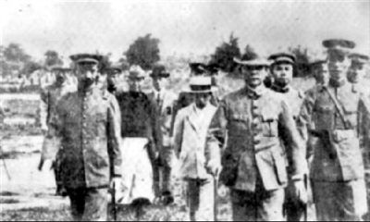
Huang Guomin did his utmost to support Sun Yat-sen's revolutionary cause, and he also had the support of his family (his wife and son were both members of the Kuomintang). In addition to leading the way in donating money himself, he also actively mobilized local overseas Chinese to donate. In 1914, Huang Guomin, on the orders of Dr. Sun Yat-sen, directly remitted the huge sum of money raised in Wellington, New Zealand, to the headquarters in Tokyo, Japan, to support Sun Yat-sen's revolutionary struggle and the "anti-Yuan" struggle. The two donation books used at that time, as well as the postal receipts (in English) for the international postal remittance to Tokyo, are still well preserved. The donation register is titled "Australia's West Coast Province Fundraising Department for the Third Revolutionary Army in China (No. 1) Established in November of the Third Year of the Republic of China," and the first page contains "Regulations for Pre-Revolutionary Fundraising." The register records donations from over 400 overseas Chinese.
In 1922, Huang Guomin returned to China from New Zealand to participate in the revolution on the orders of Sun Yat-sen. He arrived in Hong Kong in late July and, after contacting the Grand Marshal's Office in Guangzhou, learned that Mr. Sun Yat-sen had already travelled to Shanghai on the Yongfeng warship. Soon after, the Shanghai headquarters telegraphed Huang Guomin, inviting him to Shanghai to meet with Sun Yat-sen. Mr. Huang Guomin discussed party and national affairs with Sun Yat-sen. In late September, after arriving in Shanghai, he was forced to leave the city, so the headquarters arranged for him to meet with various party and government officials in Shanghai. Huang Guomin then returned to Hong Kong in November. After Chen Jiongming betrayed the revolution, he retreated to Huizhou on December 16, 1922. To suppress Chen Jiongming, Sun Yat-sen returned to the provincial capital on January 6, 1923, aboard the Yongfeng warship. Huang Guomin travelled with Sun Yat-sen on the same ship. This was Huang Guomin's first meeting with Sun Yat-sen.
Huang Guomin greatly admired and respected Sun Yat-sen. The Premier felt immensely pleased and honored. The two spent a long time together on the ship, engaging in very intimate conversations. Their topics ranged from donating funds to support the National Revolution to discussing party and national affairs—they covered everything. After arriving in Guangzhou, Huang Guomin donated 1,000 taels of silver to support the struggle against Chen Jiongming. Upon returning to Guangzhou, the Grand Marshal's Office appointed Huang Guomin as the "Quartermaster of the 10th Route Army of the Overseas Chinese Anti-Bandit Army" and to assist the provincial government. At that time, due to the vacancy of the position of County Magistrate of Zengcheng, Governor Xu Shaozhen appointed Huang Guomin as the County Magistrate of Zengcheng and concurrently the Minister of the Kuomintang Zengcheng County Party Headquarters.
During his tenure, Huang Guomin resolutely implemented provincial government decrees, cracked down on local tyrants and evil gentry, and eradicated bandits. In particular, on June 12th, he cooperated with Commander Li Hanhun to wipe out the stubborn bandit Yuan Xiajiu in Zengcheng, maintaining local security. At the same time, he emphasized water conservancy projects, dike construction, agricultural development, and vigorous promotion of education, achieving considerable political success. However, due to intense internal struggles within the Kuomintang, the rise of local evil forces, and other reasons, he was forced to resign from his positions as magistrate of Zengcheng County and head of the county party committee a year later. Afterwards, he served as a member of the "Central Committee of the Communist Party of China." Huang Guomin was the commander of the 3rd Brigade of the 4th Division of the Western Route Anti-Bandit Army directly under the Central Government. After joining the democratic revolution, he established a deep revolutionary friendship with Sun Yat-sen.
During his time back in China, around the Spring Festival each year, Huang Guomin would bring a basket filled with New Year's treats such as sugar rings and cakes to visit Sun Yat-sen at the Presidential Palace. On one occasion, the presidential guards, seeing him dressed as a peasant, refused to let him in. Guomin said, "Please tell Premier Sun that Minzi has come to visit him." Whenever Sun Yat-sen heard that Guomin had come to see him, he was very happy to receive him and affectionately called him "Minzi." Huang Guomin then took his leave. After becoming the magistrate of Zengcheng County, he continued to care about and support the National Revolution. Drawing on his own experience, he analyzed the current situation of the democratic revolution and wrote a "political opinion letter" to Sun Yat-sen, praising his loyalty to the revolution.
On March 12, 1925, Sun Yat-sen unfortunately passed away in Beijing. The news of his death caused immense grief to the nation, and Wong Kwok-min was saddened by the loss of a pillar of the country and a close friend. Subsequently, the Nationalist government gradually declined, leading to a situation of military competition. The people were worried about the state of the nation and lost faith in the revolution. Soon after, he declined the Nationalist government's offer to stay and resolutely went abroad again. After returning to New Zealand, he devoted himself to business, abstaining from politics, and lived out his days abroad at the age of 62.
Huang Guomin's wife, Liu Cuixian (Whitely Wong), a native of Xiancun, was a Kuomintang official. During her tenure, in addition to supporting her husband's work, she actively mobilized overseas Chinese women to donate to support the revolution. Due to overwork, she unfortunately passed away in New Zealand. The Presidential Office Secretary-General, Xie Chi, sent a letter of condolence to New Zealand on behalf of the Presidential Office, mourning this outstanding overseas Chinese woman.
https://www.520zc.com/article-473-1.html

追随孙中山革命的增城新塘黄国民
11-1-22 16:34| 发布者: lujunfei| 查看: 2114| 评论: 0
摘要: 黄国民是增城市华侨,原籍新塘镇瓜岭村人.原名黄锡堪,自幼随父母及兄锡培,锡树,弟锡林侨居新西兰.早年受新文化新思想熏陶,支持和参加孙中山的革命活动,遂改名为“国民”,以表示对革命的决心.国民自幼随父母侨居新西兰 ...
黄国民是增城市华侨,原籍新塘镇瓜岭村人.原名黄锡堪,自幼随父母及兄锡培,锡树,弟锡林侨居新西兰.早年受新文化新思想熏陶,支持和参加孙中山的革命活动,遂改名为“国民”,以表示对革命的决心.国民自幼随父母侨居新西兰.受到革命思想薰陶,积极参加反帝,反清,开展民主革命活动,很早成为一名国民党员,并担任国民党新西兰威令顿埠支部正部长.在任职期间工作积极,成绩突出,为华侨做了许多有益的工作,在华侨中享有较高的威望.
黄国民竭其所能支持孙中山革命事业,并得家人的支持(妻子,儿子都是国民党员).除自己带头捐款外,他还积极发动当地华侨捐款.民国3年(1914),黄国民奉孙中山先生之命,把在新西兰威令顿埠筹得的巨款直接汇往日本东京总部,及时支持孙中山革命斗争和“讨袁”斗争.当时用的两本捐款册以及由国际邮政汇款往东京的邮政收据(英文),至今保存完好.捐款册名称“澳洲细丝伦省筹助中国第三次革命军饷部(天字第一号),民国三年十一月立”,首页有“第三次革命事前筹饷章程”.名册记录有400多位华侨捐款.
民国11年(1922),黄国民奉孙中山之令从新西兰回国参加革命,7月下旬到达香港,经与广州大元帅府联系,得知孙中山先生已乘永丰战舰前往上海.不久,上海总部来电邀请黄国民前往上海与孙中山先生共商党事国事.9月下旬,到达上海后,刚好孙中山先生有事离沪,总部只好安排国民拜见在上海的各党政要员,后于11月回港.陈炯明背叛革命后,于民国11年l2月16日退守惠州.为了讨伐陈炯明,民国l2年(1923)元月6日孙中山先生乘永丰战舰返省城,黄国民与孙中山先生同乘该舰回来.这是黄国民第一次见到孙中山先生.
黄国民非常崇拜和敬仰孙总理,心里感到无限高兴和荣幸.两人在船上相聚多时,交谈非常亲密,内容从捐款支持国民革命到共商党事,国事,无所不谈,到广州后,国民捐出一千饷银支持讨伐陈炯明的斗争.回到广州后,大元帅府任令黄国民为“华侨讨贼军第十路司令部军需长”,并协助省政府工作.当时,由于增城县长职位空缺,省长徐绍桢委任黄国民为增城县县长,兼国民党增城县党部部长.
黄国民在任职期间,国民坚决执行省政府法令,打击土豪劣绅,肃清土匪,特别是六月十二日配合李汉魂军长剿清增城顽匪袁虾九,维护了地方治安.同时,重视兴修水利,修筑堤围,发展农业,大力兴办教育,颇有政绩.圃羊碱合古后由于当时国民党内部斗争激烈,加上地方恶势力抬头以及种种原因,迫使他一年之后辞去增城县长及县党部部长之职.此后,一直出任“中央直辖西路讨贼军第四师第三旅旅长”.投身民主革命后,黄国民与孙中山建立了很深的革命友谊.
回国期间,每逢春节前后,黄国民便拿着盒箩(盒箩里装满糖环饼等年品),到总统府探望孙中山.有一次总统卫兵见他一身农民打扮,不让他进去.国民说：“请转告孙总理,民仔来探他.”孙中山先生一听到国民找他,都很高兴地接待他,并亲切地叫他“民仔”.黄国民辞去增城县长后,仍关心和支持国民革命.他结合自己的亲身经历,分析当前民主革命的形势后,给孙中山先生写了一篇“政见书”,提出慎重彭素民代笔给黄国民回信,赞扬他对革命的忠诚.
民国l4年(1925)3月12日,孙中山先生不幸于北京逝世.噩耗传来,国民悲痛万分,他因国家失去栋梁,自己失一知己而难过.此后,国民政府日渐衰落,出现军事争雄局面,国民对国势感到忧愁,对革命失去信心.不久,他谢绝了国民政府的挽留,毅然再度出国.回到新西兰后,他以经商为业,不问政治,终老于国外,享年62岁.
黄国民妻子刘翠贤,仙村人,国民党干事,在职期间,除支持丈夫工作外,还积极发动华侨妇女捐款支持革命.因积劳成疾,不幸于新西兰病逝.总统府秘书长谢持以总统府名义发唁函到新西兰,悼念这位华侨女杰.
https://www.520zc.com/article-473-1.html

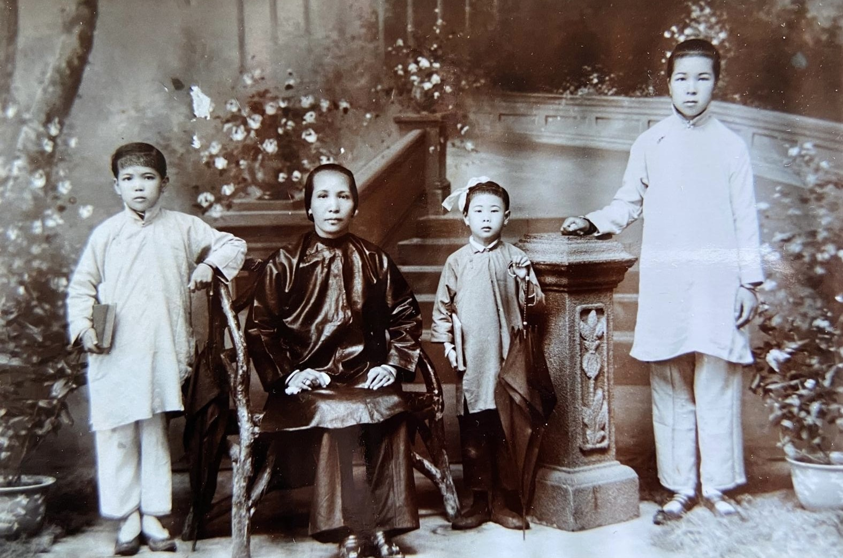Wong Kwok-min’s first wife and children Alison Wong collection
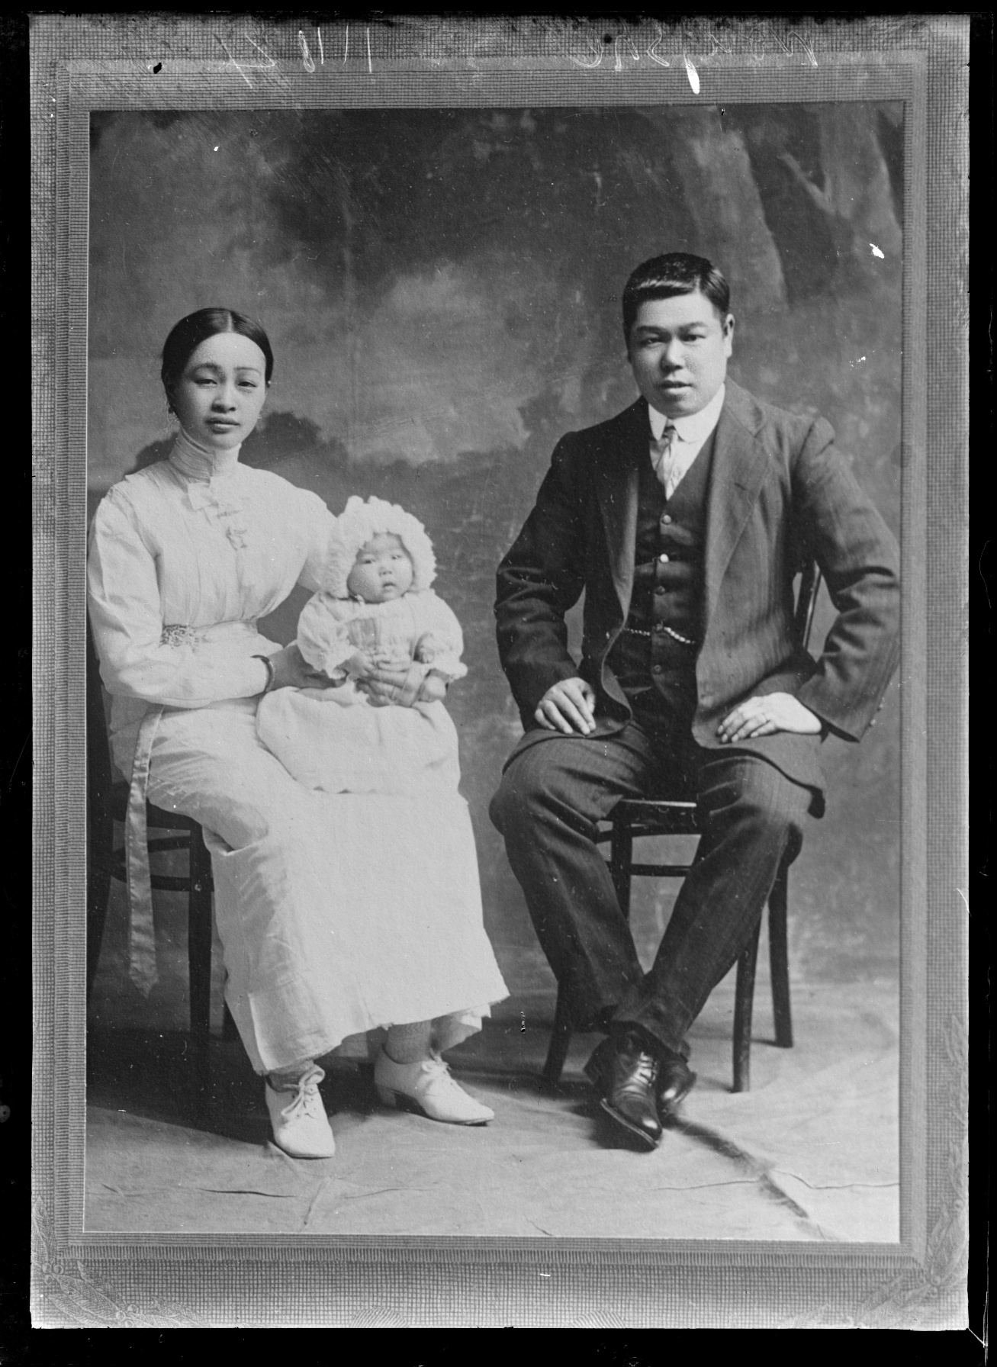
Wong Kwok-min and his second wife Whitely Wong with their daughter Alice ca 1910 MA_I301768_TePapa_Sik-Hum-Wong-Leik-Choy_13.2MB

